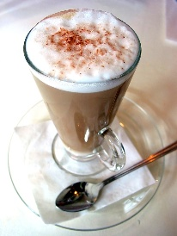Computer 8 Lab 2

## Part 1:

The following is output for Project 2-2 in your book on page 54. Make this same project but instead of the word YIELD use your first name.

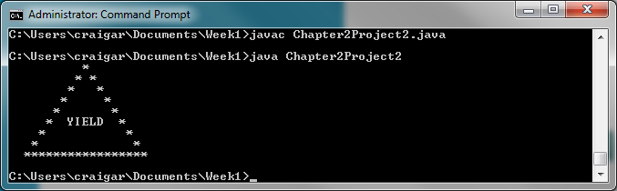

Paste a screenshot of your program running and of the code below.

## Part **2:**

Complete Project 2-4 on page 55. Paste a screenshot of your code and an example program run below.

## Part **3:**

Complete Project 2-7 in your gook on page 55 except make the boxes be yellow and green instead of black and white. Except for the color it should look like this:

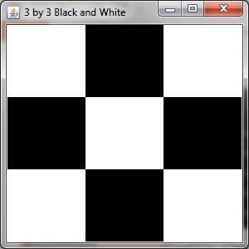

Paste a screenshot of your program running and of the code below.